ServiceMix JBoss ESB Comparison and Recommendation

Version No: 1.0
Last Modified: 10/07/2008

Author : Mukesh Mediratta
Team : caXchange

Client : National Cancer Institute - Center for Bioinformatics,
National Institutes of Health,
US Department of Health and Human Services

Document History

Document Location
The most current version of this document is located in CVS.

Revision History
Version Number | Revision Date | Author | Summary of Changes
1.0 | 05/14/08 | Mukesh Mediratta | Initial draft
1.0 | 10/17/08 | Harsh Marwaha | Reviewed and edited

Review
Name | Team/Role | Version | Date Reviewed | Reviewer Comments

Related Documents
More information can be found in the following related documents:
Document Name
caXchange Hub Use Case Document
caXchange Requirements and Specifications Document (SRS)
Hub Evaluation and Recommendation Document

Table of Contents
1. Introduction 3
1.1 SCOPE 3
1.2 Evaluation methodology 3
1.3 Reference Documents 3
2. Evaluation Criteria 4
2.1 Compliance with caBIG™ Principles 4
2.2 Compliance with Published NCICB Technology Stack 4
2.3 Compliance with JBI Specifications (JSR 208) 4
2.4 Supported Operating Systems 5
2.5 Application Level Security 6
2.6 Transport Level Security 6
2.7 Built in Support for Guaranteed Messaging 6
2.8 Message Mediation 6
2.9 Workflow Orchestration 6
2.10 Management Console 7
2.11 Quality of Documentation 7
2.12 Installation Flexibility 7
2.13 Integrated Development Environment 8
2.14 Out of the Box Components and Services 8
2.15 Evaluate effort required to migrate from Servicemix to JBossESB. 8
3. Software Evaluation Matrix 9
4. USE CASES 13
4.1 Apache Servicemix 3.1.2 13
4.1.1 Administration 13
4.1.2 Application Interface 14
4.1.3 Loan Broker – Sample Application 14
4.2 JbossESB 17
4.2.1 Administration 17
4.2.2 Application Interface 19
5. Effort required for Migration from Apache Servicemix to JBossESB 21
6. Conclusions and Recommendation 22

Introduction
The caXchange Hub is the software component that is primarily responsible for receiving input from various external systems, routing the input to various services that are hosted on the hub, and eventually routing the output of those services to external systems. caXchange is implemented using Servicemix 3.1.2 enterprise service bus (ESB) for routing and exposing that functionality using a service deployed on caGrid. caXchange is deployed as a service assembly on Servicemix 3.1.2. caXchange grid service acts as a proxy to the service assembly.

In June 2006 when this project was initiated an evaluation criteria was developed and various open source software products available at that time were evaluated and compared. A recommendation was made to select Logic Blaze Fuse (a product based on Apache Servicemix) which was subsequently replaced by Apache Servicemix. For more details on this please refer to “Hub Evaluation and Recommendation Document”.

Apache Servicemix 3.1.2 has been used to implement caXchange 1.1 and 1.5.

SCOPE
Scope of this document is limited to Apache Servicemix and JbossESB only. The evaluation methodology as detailed in section 1.2 has been used for evaluation and recommendation of the product

Evaluation methodology
The evaluation steps taken for the assessment of the software required for Information Hub included the following steps:
- A set of evaluation criteria have been developed based on the overall goal of the project, compliance with caBIG principles, published NCICB future technology stack, and stated requirements.
- A preliminary screening of the features offered by each product was conducted
- Products were installed on a development machine The examples included as part of the each product’s installation were tested and the product management consoles were used to start/stop applications. Each product’s published documentation has been reviewed and compared against the evaluation criteria as well. The comparison matrix thus generated has been included as part of this document.
- With the objective of meeting project goals a few use cases have been used to evaluate the short-listed product. This document includes details of the use cases, experiments conducted and the results.
- Based on the comparison matrix and use case results recommendation has been made for the product suited for the project.

Reference Documents
For additional project, and requirement specific information, refer to the following documents:
- caXchange Hub Use Case Document
- caXchange Requirements and Specifications Document (SRS)

Evaluation Criteria

Compliance with caBIG™ Principles
As the caBIG program is the primary sponsor, all work performed for this project must be done in compliance with the caBIG principles. Software that is used and/or developed in the context of this project must be caBIG™ compatible at the silver level (https://cabig.nci.nih.gov/guidelines_documentation/caBIGCompatGuideRev2_final.pdf) and be made available to the community through resources provided by the General Contractor. These requirements are
- Open Source
- Open Development
- Open Access
- Federation

Compliance with Published NCICB Technology Stack
The Information Hub has been proposed based on JBI (Java Business Integration) and J2EE standards and it must be in compliance with the published NCICB Technology Stack (http://gforge.nci.nih.gov/docman/view.php/27/2380/caCORE31TechnologyUsage.xls) and be compatible with
- J2EE 1.4
- Java 1.5.0_06

Compliance with JBI Specifications (JSR 208)
The overall goal of the project is to build a hub system that can be adapted and extended to multiple data formats and whose value and usability can be pilot tested in one or more cancer centers. This objective is best served by building hub based on Java Business Integration (JBI) Architecture.

JBI is based on JSR 208 specifications (http://www.jcp.org/en/jsr/detail?id=208). The objective of JBI standard is to provide a standard Message Exchange Patterns (MEPs) and Service Provider Interface (SPIs) for business integration, to provide standards for interfaces for key components in an integrated runtime environment.

The specifications opens the way for integration of multiple technologies such as B2B, BPEL, Messaging, Transformation, Scripting etc. in a standard way, leading to a true component based design.The JBI Specification defines three types of technologies: Service Engines (SE s), Binding Components (BC s) and integration environment. SEs provides business logic and transformation service to other components. BCs provide connectivity to services external to JBI installation. BC’s convert protocol and transport specific messages such as HTTP, SOAP, FTP messages to a normalized format

A key feature of JBI specifications is the insistence on interfaces - not the internal structure – of Service Engines and Binding Components. Except for their interfaces to the integration environment, the components are “black boxes”, which makes them loosely coupled and can be easily swapped with any other equivalent components.

Besides the interfaces JBI places only two requirements on SEs and BCs: that the exchanges between components and environment be message based (the MEPs) and that the interaction be defined in a standardized manner (the SPIs, typically expressed in WSDL)
SEs and BCs interact using a standard internal normalized message format (based on XML) and the exchanges happen using JBI runtime engine based on a Normalized Message Router (NMR)
Following diagram depicts a simple view of a JBI Container. Application A is an existing application, which has a need to exchange the data with an incompatible application, Application B.
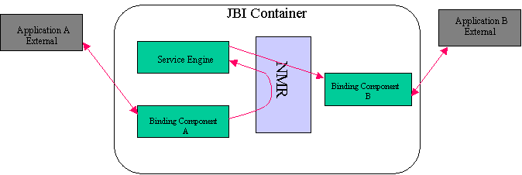

Based on the JBI Specifications following requirements have been selected as part of hub evaluation criteria:
- Pluggable and Swappable Service Engines
- Pluggable and Swappable Binding Components
- Support for Normalized Message Format for internal messaging
- Normalized Message Router
- Loosely Coupled Services
- Standard Message Exchange Patterns
- WSDL and Service Registry Support
- XML- Centric Messages
- JBI Management Beans
- Tools for Management and Installation of Components/Services
- Support for JBI Deployment Units and Components

Supported Operating Systems
The Hub should be able to deploy on popular operating systems identified below. Specifically Linux being an open source OS, should be supported
- Linux
- Any Unix Platform that supports Java
- Windows XP SP2
- Windows 2000

Application Level Security
To authenticate and enforce access controls upon users of Hub, JBI specifications drive a need to have a flexible API to provide access to JAAS providers, and/or plug in an Authentication Module. Following features are required to evaluate Application Level Security.
- Support Java Authentication and Authorization Service (JAAS)
- Support Pluggable Authentication Module Framework (PAM)
- Support User-Based Authentication
- WS-Security

Transport Level Security
The need for secured communication with cancer centers, clients and partners require support for:
- SSL
- HTTPS

Built in Support for Guaranteed Messaging
For a messaging hub guaranteed messaging is a fundamental requirement. “Guaranteed Messaging” has a number of dimensions, including:
- Transactional: ensuring completion of a process, even if the process is a composite application.
- Message Persistence: continuing to persist the state of message exchange that is stopped, which may be due to failure of messaging subsystem, network or recipient.
- Recoverability: the ability to restart a persisted message exchange at the point in the process where it had stopped.
- Exactly Once Delivery: ensuring that a message is delivered once and only once to avoid duplicate processing of a process or a transaction.
- Secrecy: protecting information from disclosure to outside parties.

Message Mediation
As message moves from one point to another, multiple mediating activities can take place. These activities include:
- Smart Routing: As a message moves from one point to another there may be a need for routing the message from one destination to another, placing one message ahead of another in a queue, invoking other mediating activities.
- Transformations: are the changes in data format in which message is presented to the target
- Validation: validation of content or format or context etc to allow or prevent it to proceed further.

Workflow Orchestration
Orchestration is an ability to specify the sequence of services that comprise a composite application and to execute that sequence in response to the appropriate request. BPEL has emerged as a leading standard for managing composite applications as such support for BPEL is one of the evaluation criteria. Although BPEL may not be implemented during the 1.5 release of the project, it is important that the product chosen can support or supply the following:
- BPEL Service Engine
- BPEL Development Tool

Management Console
Information Hub consists of several individual SEs, BCs and lightweight components. There is a need to have a centralized monitoring and management tool for administration of Hub and its various components.
- JMX Interface: JMX interface provides a capability to take a feed of runtime parameters and statistics. This data is displayed on console for the Hub administration and tuning purposes.
- Start/Stop Processes: Ability to start to stop processes from console is better than running commands from the command line.
- Hot Deploy/UnDeploy Components: Ability to deploy and undeploy components at run time using console.
- Monitor Component Performance: Parameters like message throughput, message count, messages in the memory, messages buffered (inbound and outbound) for hub and individual components.

Quality of Documentation
Quality of documentation is an important factor, as it would help application developers and administrators during the development, deployment and production phases of the project. The list of documentation that will be evaluated is provided below:
- User Manuals
- Installation Guides
- Developer Guides
- Example Use Cases

Installation Flexibility
Flexibility in terms of being able to install either standalone or embedded in an application component or as part of services supported by an application server allows the component reuse through out the enterprise.
- Standalone
- Embedded in an application component.
- Part of Application Server

Integrated Development Environment
An Integrated Development Environment would greatly enhance developer productivity.

Out of the Box Components and Services
Out of the Box components and services engines are that can easily be modified or deployed on the Hub as is are very important for the project. For the current and future requirements, we are evaluating the availability of the following components:
- Email – Support for sending email messages like critical admin support requirements etc.
- HTTP/HTTPS – Send and receive messages using HTTP
- JMS – Send and receive messages using JMS
- FTP – Send messages to a FTP Server as files. Poll a FTP location for incoming files
- BPEL – Message Orchestration Engine
- Rules Engine – Support for smart routing based on Rules.
- Scripting – Support for scripting language, required for routing, validation and transformation messages.
- XSLT Transformation – Transformation Engine based on XSLT (Spreadsheet) template
- Validation – Component for validating messages using XML Schema
- Scheduler – Support for a built in timer for scheduled service invocations.
- SAAJ – Support for invoking Web services using SOAP with attachments and Apache AXIS.

Evaluate effort required to migrate from Servicemix to JBossESB.
caXchange is currently developed using Servicemix. Besides comparing the feature offerings from Servicemix and JbossESB we need to evaluate the actual effort required to migrate the current caXchange code from Servicemix to JBossESB, for us to be able to draw out a more realistic picture.

Software Evaluation Matrix
Following steps were performed on each of the products Apache Service Mix 3.1.2 and JBoss ESB 4.3 GA Release:
- Install the executable version of the software on Windows XP Professional SP2 in the lab.
- Install the source code version of the software on Windows XP Professional SP2 in the lab. Build the executable version from the source version of the software.
- Review the product documentation, installation guides, features guide, case studies, and white papers. Visit the product family websites and see the supporting products.
- Install and run the example cases enclosed with the software. Monitor results
- Start the management console and monitor the performance of different components of ESB. Try to start/stop/deploy/un deploy the components.
- Join the community forums and open tickets. Check out the response time and quality of the response.
The results are as follows:

S. No. | Criteria | Apache Service Mix 3.1.2 | JBossESB 4.3 GA
1 | Compliance with caBIG Principles
 | Open Source | Yes | Yes
 | Open Development | Yes | Yes
 | Open Access | Yes | Yes
 | Federation | Yes | Yes
2 | Compliance with Published NCICB Future Technology Stack
 | J2EE 1.4 | Yes | Yes
3 | Compliance with JBI Specifications (JSR 208) | Yes | No (Will potentially support JBI 2.0)
 | Pluggable and Swappable Service Engines | Yes | No but it has its own pluggable architecture
 | Pluggable and Swappable Binding Components | Yes | No
 | Support for Normalized Message Format for internal messaging | Yes | No
 | Normalized Message Router | Yes | No
 | Loosely Coupled Services | Yes | Yes
 | Standard Message Exchange Patterns | Yes | No
 | Service Registry | Yes (Support based on JBI built in feature) | Yes
 | XML- Centric Messages | Yes | Yes
 | JBI Management Beans | Yes | No
 | Tools for Management and Installation of Components/Services | Yes | Yes
 | Support for JBI Deployment Units and Components | Yes | No
4 | Supported Operated Systems
 | Linux | Yes | Yes
 | Any Unix Platform which supports Java | Yes | Yes
 | Windows XP SP2 | Yes | Yes
 | Windows 2000 | Yes | Yes
5 | Application Level Security
 | Support Java Authentication and Authorization Service (JAAS) | Yes | Yes
 | Support Pluggable Authentication Module Framework (PAM) | Yes | Yes
 | Support User-Based Authentication | Yes | Yes
 | WS-Security | Yes(Apache CXF) | No
6 | Transport Level Security
 | SSL | Yes | Yes
 | HTTPS | Yes | Yes
7 | Built in Support for Guaranteed Messaging
 | WS-Reliable Messaging | Yes(Apache CXF) | Yes
 | Transactional | Yes | Yes
 | Message Persistence | Yes | Yes
 | Recoverability | Yes | Yes
 | Exactly Once Delivery | Yes | Yes
 | Secrecy | Yes | Yes
8 | Message Mediation
 | Smart Routing | Yes | Yes
 | Transformation | Yes (Saxon) | Yes ( Smooks Transformer )
 | Validation | Yes | Yes
9 | Workflow Orchestration
 | BPEL Service Engine | Yes (PXE) | Yes(jBPM/Active BPEL)
 | BPEL Development Tool | Incubation | Incubation
10 | Management Console
 | JMX Based | Yes | Yes
 | Start/Stop Processes | Yes | Yes
 | Hot Deploy/UnDeploy Components | Yes | Yes
 | Monitor Component Performance | Yes | Yes
11 | Quality of Documentation
 | User Manuals | Poor | Good
 | Installation Guides | Poor | Good
 | Developer Guides | Not Present | Good
 | Example Use Cases | Yes | Yes
12 | Installation Flexibility
 | Standalone | Yes | Yes
 | Embedded in an application component | Yes | No
 | Part of Application Server | Yes | Yes
13 | Integrated Development Environment | Yes
13 | Integrated Development Environment | Yes | Yes
14 | Out of the box Components and Services
 | Pojo | Yes | Yes
 | EIP | Yes(Camel and Integrated EIP SE) | Yes(Integrated EIP Implementation)
 | Email | Yes | Yes
 | HTTP/HTTPS | Yes | Yes
 | File | Yes | Yes
 | FTP | Yes | Yes
 | JMS | Yes | Yes
 | BPEL | Yes | Yes
 | Rules | Yes(Drools or XPath) | Yes(Jboss Rules, Drools or Xpath)
 | Scripting | Yes | Yes(Groovy)
 | XSLT Transformation | Yes | Yes
 | Validation | Yes | Yes
 | Scheduler | Yes | Yes
 | SAAJ | Yes | Yes
14 | Project Status
 | Incubation
 | Version Ready for Deployment | Yes | Yes
15 | Training and Support
 | Free Community Support | Yes | Yes
 | Paid Developer Level Commercial Support with SLA | Yes | Yes
 | Paid Production Level Commercial Support with SLA | Yes | Yes
 | Paid Product Training | Yes | Yes

.

USE CASES

Apache Servicemix 3.1.2

Administration
In this use case we performed following activities:
- Test Ease of Installation – Servicemix3.2.1 code was downloaded from the http://servicemix.apache.org. The code is available as binary distribution as well as source distribution. Both distributions were downloaded in the lab on a Windows XP SP2 machine; instructions were followed in the enclosed documentation for installation of the product. Product got installed in first attempt in a matter of few minutes.
- Check the enclosed documentation – User level documentation is available on the website. The documentation has to provide more details to be effective.
- Start/Stop the Server in standalone mode – Servicemix server was started using the instructions in the enclosed documentation; Server came up cleanly. No instructions are provided for stopping the server. A CTRL-C on the console window was used to stop servicemix.
- Test Management Console Features –Sericemix provides a JMX Console and it also provides a web based Console. These consoles provide the following functionalities:
  - JBI Container – Displays software version of the JBI Container, Status (stopped/started). Allows user to start/stop the container.
  - System Service – Displays status of all the JBI system services and allows the user to start/stop the services. Some of these services are installation service, broker service, AdminCommandService, AutoDeploymentService etc.
  - JBI Components – Displays JBI Component details like - type of component (SE/BC), Status (Stopped/Started), and lets administrator start/stop a component.
  - Components Statistics – Polls the log files every second and display the information like inbound rate/count, outbound rate/count of messages, queue size etc.
  - Archives Installed/Deployed – Allow to install/uninstall and deploy/undeploy service assemblies and units. Displays the current status of these components.
  - Brokers – Lists the running Apache ActiveMQ Message Brokers
  - Queues – Monitors Apache ActiveMQ Queues
  - Topics – Monitors Apache ActiveMQ topics

Application Interface
As part of hub requirements we have identified following as key requirements which we would like to test using sample applications
- Ability to receive SOAP Messages using Web service calls from client
- Ability to use a BPEL engine to orchestrate the messages
- Ability to invoke applications like C3PR, caAERS, PSC etc using caGrid.
- Ability to invoke external web services to access applications.
We have a sample application, which came bundled with Apache Servicemix; we used this application to test our individual requirements. These application is described in following section:

Loan Broker – Sample Application
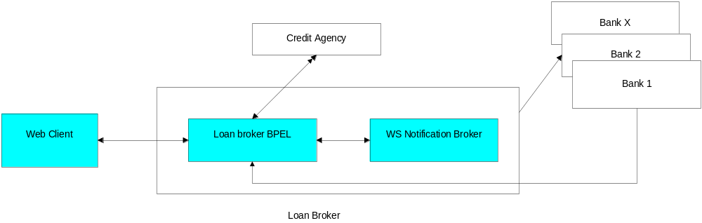

In this use case
- The web client requests a loan rate from the Loan Broker system
- The loan broker BPEL service engine asks the Credit Agency for the credit rating of the loan requester.
- The loan broker solicits the best loan rate from multiple banks. The WS-Notification service engine sends the request amount, duration, and the loan requesters credit score to the banks.
- The bank responds to the loan broker with the best loan rate.
- The loan broker determines which bank had the best rate and returns that information to the requester (web client)

This use case is implemented with two banks. The message flow in the application is as follows
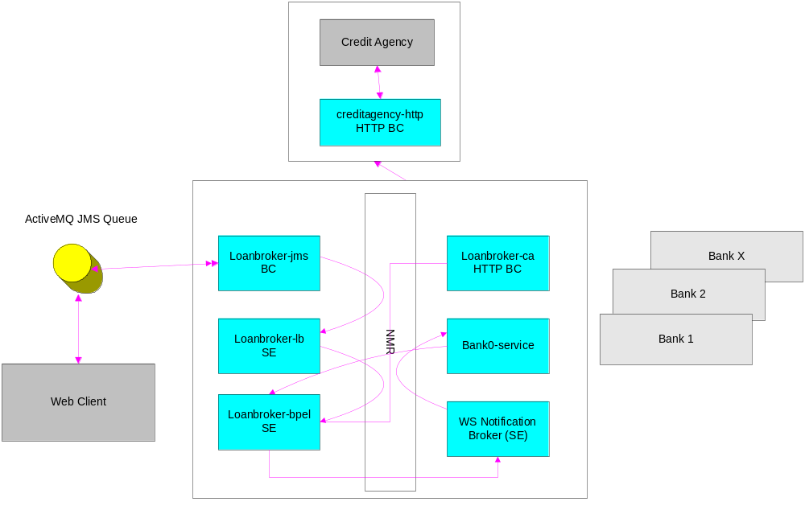
Message Flow

- The web client is loan requester. It requests a loan rate by publishing a JMS message on an ActiveMQ queue.
- Loanbroker-jms receives the message. Loanbroker-jms is a binding component that can receive and process JMS messages. Loanbroker-jms will normalize the incoming message. Normalizing the message will put it in the neutral format that is used within the JBI system. After normalization, loanbroker-jms will pass the message along the intended recipient via the Normalized Message Router (NMR). In this case loanbroker-lb is the message recipient. Loanbroker-jms implements the In-Only Message Exchange Pattern (MEP).
- Loanbroker-lb is a front end to the BPEL process. Loanbroker-lb is a service engine (SE) and its job is to take the loan request and pass it to the loanbroker-bpel process. It then waits for a reply from the BPEL process. The loanbroker-lb is an aggregator; it receives an In-Out MEP on a callback endpoint. The response is sent back to the consumer as the Out message of the In-Out MEP.
- The loanbroker-bpel process receives the loan rate request. As the BPEL process is asynchronous, the incoming MEP for loanbroker-bpel is In-Only and the response is sent as In-Only MEP to a callback endpoint.
- First loanbroker-bpel must obtain the credit rating of the requester. To do this the BPEL process sends a message over the NMR to the loanbroker-ca process.
- Loanbroker-ca is a binding component. It translates the normalized message (which contains a credit rating request into a HTTP-SOAP message. This is done so that loanbroker-ca can communicate with the creditagency-http binding component. The MEP for the loanbroker-ca is In-Out.
- The creditagency-http BC passes the credit rating request to the creditagency-service.
- The creditagency-service processes the request and response. The response is sent back via a SOAP message over HTTP to the creditagency-http binding component.
- The creditagency-http binding component receives the HTTP+SOAP response from the creditagency-service and passes it to the loanbroker-ca binding component, also via HTTP-SOAP.
- Loanbroker-ca normalizes the HTTP-SOAP message and sends it over the NMR to the loanbroker-bpel process.
- Now that the BPEL process has the credit score information it can send the loan rate request to the banks. The loan request for the bank is sent to a WS-N process. This component would normally notify a group of banks of the request. The message exchange pattern for the loanbroker-bpel is In-Only.
- bank0-wsn sends the loan request to Bank 0. The MEP is In-Only.
- bank0-service processes the loan request and sends a response back to loanbroker-bpel using an In-Only MEP
(Please note: In order to reduce the complexity message flow only for Bank 0 is shown. For other banks message flow has not been shown)

Jboss ESB

Administration
In this use case we performed following activities:
- Test Ease of Installation – JBossESB was downloaded from the http://www.jboss.org. The code is available as binary distribution as well as source distribution. Both distributions were downloaded in the lab on a Windows XP SP2 machine; instructions were followed in the enclosed documentation for installation of the product. Product got installed in first attempt in a matter of few minutes.
- Check the enclosed documentation – User level documentation is available along with the code distribution. The documentation is found to be of good quality.
- Start/Stop the Server in standalone mode – JBossESB server was started using the instructions in the enclosed documentation; Server came up cleanly. On following stop instructions the server went down also cleanly.
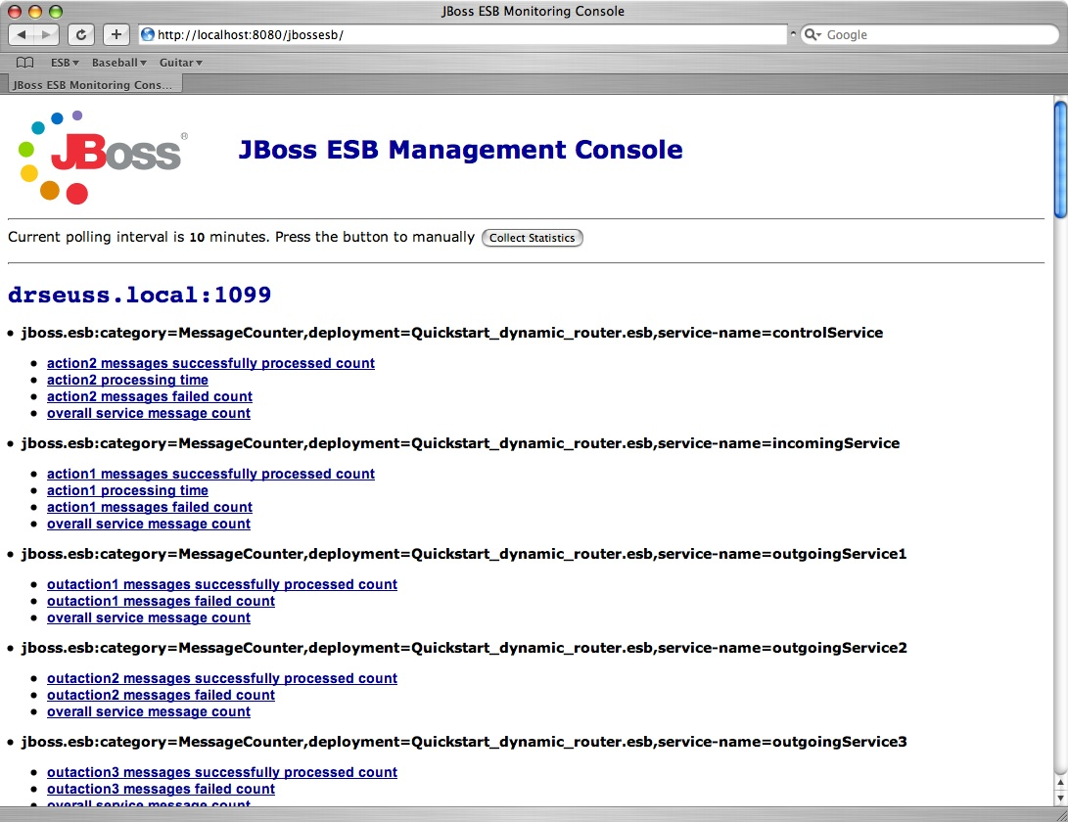
- Test Management Console Features – Below is a screenshot of the console. The console requests MBean information from each node within the ESB registry, and then displays it back. Any attribute hat is a processing time a count is shown with a chart and a time sorted list, which all other data is displayed with just a time sorted list.

There are a number of options for monitoring and managing your ESB server. Shipping with the ESB are a number of useful JMX MBeans that help administrators monitor the performance of their server.
Under the jboss.esb domain, you should see the following MBean types :

  - deployment=<ESB package name> – Deployments show the state of all of the esb packages that have been deployed and give information about their XML configuration and their current state.
  - listener-name=<Listener name> – All deployed listeners are displayed, with information on their XML configuration, the start time, maxThreads, state, etc. The administrator has the option of initialising/starting/stopping/destroying a listener.
  - category=MessageCounter – Message counters break all of the services deployed for a listener down into their separate actions and give counts of how many messages were processed, as well as the processing time of each message.
  - service=<Service-name> - Displays statistics per-service (message counts, state, average size of message, processing time, etc). The message counts may be reset and services may be stopped and started.
  - Monitoring - The JBossESB monitoring console gathers information on the performance of different ESB services that are deployed and keeps historical state information over a period of time. As of JBoss ESB 4.2.0.GA, the monitoring console allows users to get message counts by service, action, and node, as well as other information like processing time, number of failed messages, bytes transferred, and last successful and failed message date time.

Application Interface

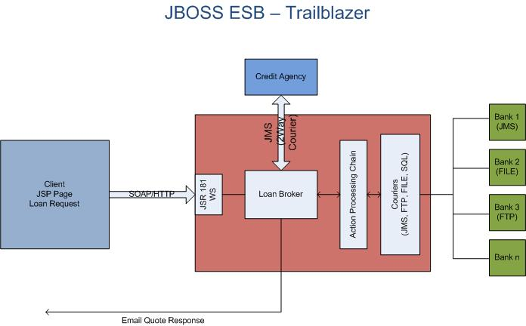

The Trailblazer(TB) is meant to show a commonly understood use-case where the JBossESB can be used to solve the integration problem at hand. The TB is loosely based on the Enterprise Applications Integration book (http://www.eaipatterns.com/). The use case is as follows:

- A user is shopping around for a bank loan with the best terms, rate, etc.
- A loan broker will act as middle-man between the user and the banks.
- The LoanBroker will
  - Gather all the required information from the user,
  - Perform a credit check, and then if a suitable credit score is returned,
  - Pass the quote request on to each bank.
  - As the quotes are received from the various banks, the LoanBroker will pass those back to the requesting user.
This is a common practice in the financial services world today – it's a model used for insurance quotes, mortgage quotes, and so on.

The sequence diagram below illustrates the full set of calls that are made in the trailblazers:

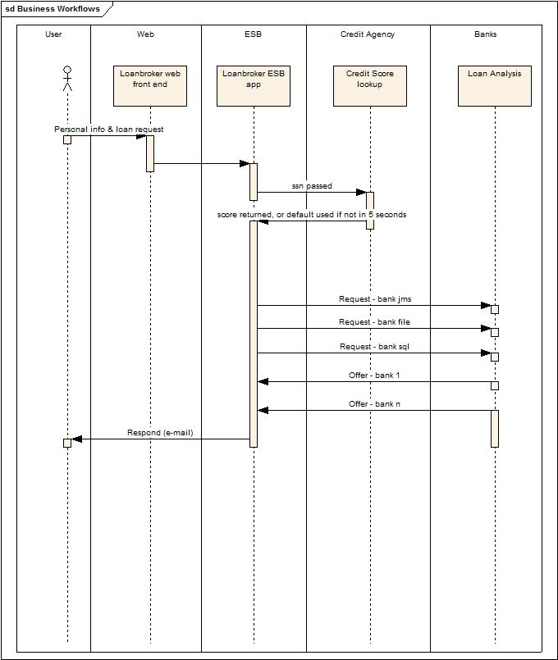

Effort required for Migration from Apache Servicemix to JBossESB
caXchange is currently implemented using Apache Servicemix 3.1.2 using JBI compliant components. The servicemix components currently being used within caXchange include:

- Servicemix-Bean
- Servicemix-EIP
- Servicemix-JMS
- Serivcemix-http

JBoss ESB is not JBI compliant. Migration effort for these components would require re-development of these components using JBoss ESB methods and techniques. We think that certain Java code developed as part of the Servicemix-Bean component can be reused in a similar component in JBoss-ESB. For the servicemix-eip component we think a major effort is required. This component defines the routing of service payloads within caXchange.

Conclusions and Recommendation
We think that both Servicemix ESB and JBoss ESB are comparable in functionality and ease of development. We think that product documentation and support is much better for JBoss ESB. However we believe a significant effort is required to move the current caXchange software to JBoss ESB. Additionally the current JBoss ESB version is not JBI compliant and therefore could result in vendor lock. We recommend continuing to use Apache Servicemix as the underlying ESB for caXchange software.

